**EE564 Project #2 Tesla Motor Design**

**Tesla RWD 85 Model Motor Parameters:**

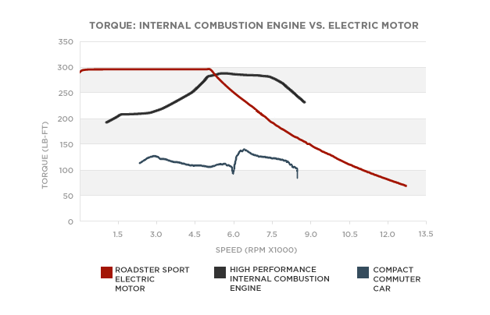

Tesla has two motor, rear wheel drives.

**Max power:** 270kW

**Max torque**: 441 Nm

**Max speed:** 225km/h (car speed)

**Max speed of the motors: $\frac{225000}{wheel diameter*pi*60}*gear ratio=16591.90 rpm$**

***Gear ratio*** *1/9.73*

***wheel diameter*** *(Michelin catalog)=245mm*0.45*2+19”=0.7metre*

**Rated Torque:** 300 LB-ft. = 406 Nm

**Rated speed:**  665 rad/s

**Is it logical about the rated speed for tesla car?**

665 rad/s=6350.28 rpm

6350.28/9.73=652.6 rpm wheel speed

52.6*60*0.7pi= 86km/h it is logical due to traffic rules.

**Pole selection**

For traction induction motors 4 pole is enough. Increasing pole number decreases the outer radius of the motor but also increases the leakage reactance.

Also tesla

<http://sites.ieee.org/miami/files/2014/11/Hendershot-FIU-Lecture.pdf>

**Why tesla is so small according to industrial Induction machine?**

[*http://www.reddit.com/r/AskEngineers/comments/2mv2h5/how_does_tesla_make_their_motors_in_the_model_s/*](http://www.reddit.com/r/AskEngineers/comments/2mv2h5/how_does_tesla_make_their_motors_in_the_model_s/)

* Liquid cooling is used in tesla.
  + Means worse efficiency and more output power with same size
* High permeability (expensive) electrical steel is used with thinner lamination.
* Cast copper is used on motor. It increasing filling factor and it is lower resistance according to aluminum.
* High input frequency is used. For rated speed and 4 pole machine

$$\frac{120f}{p}=speed \left(rpm\right)≅\frac{120}{4}f≅6000$$

$$f_{rated≅200 hertz}$$

$${ f}_{max}≅553 hertz$$

Material Selection:

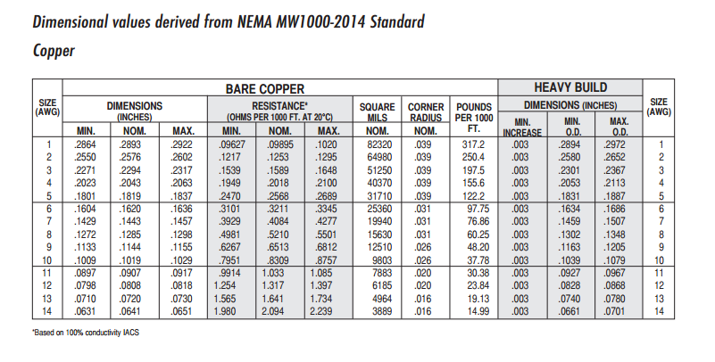

Copper selection: ?

Electrical steel selection:

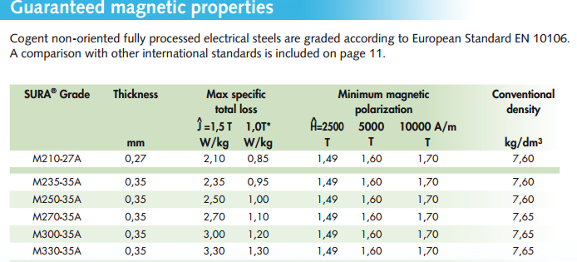

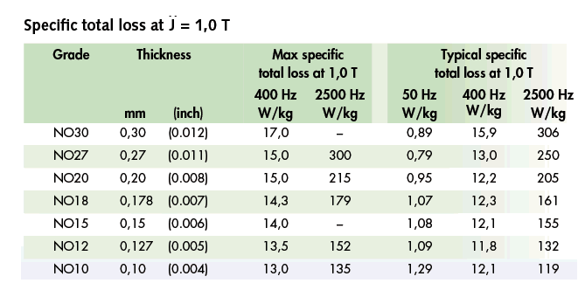

<http://www.sura.se/Sura/hp_main.nsf/startupFrameset?ReadForm>

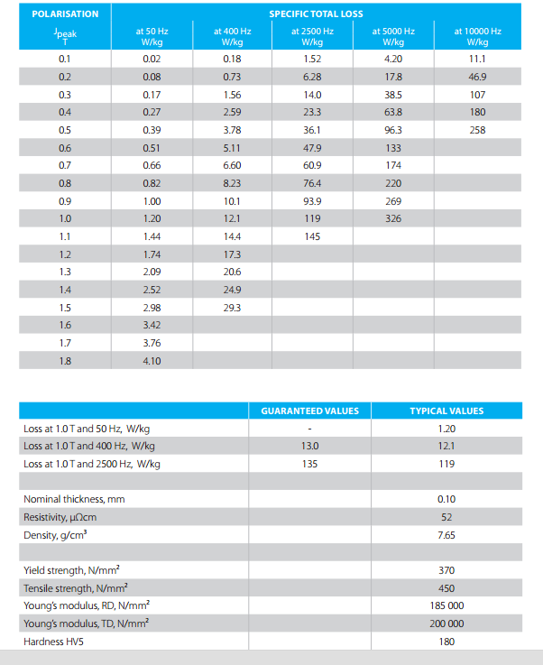

Alternative electrical steel/ better magnetic properties but worst mechanical porperties. <http://www.vacuumschmelze.com/fileadmin/docroot/medialib/documents/broschueren/htbrosch/Pht-004_e.pdf>

